**ASSIGNMENT-1**

1. **Install Power BI Desktop and share the final screenshot of the report view page which appears when power desktop starts.**

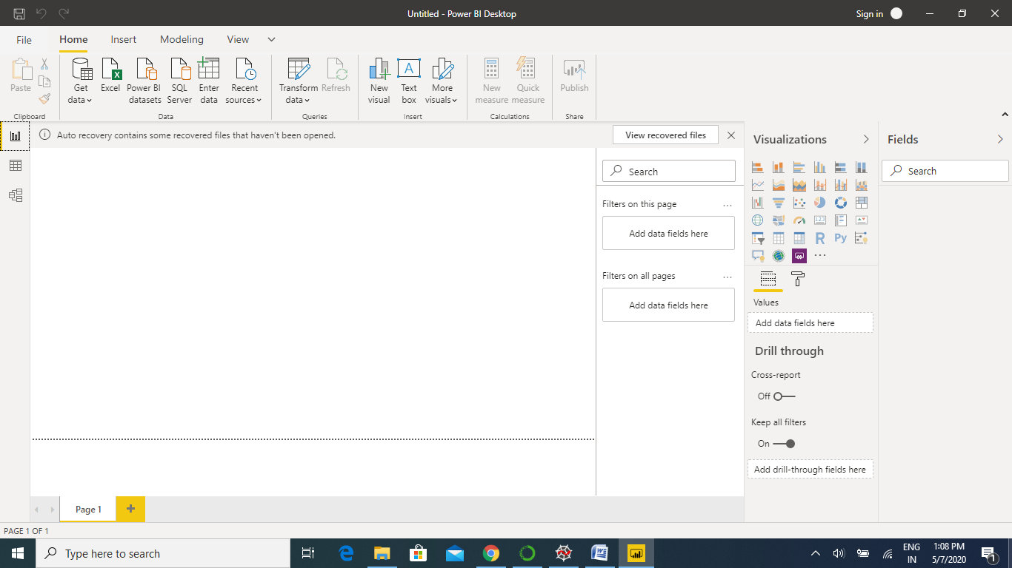

1. **Prepare a document and with the following screenshot − Report View − Data View − Model View − Power Query Editor − Advance Editor**

**Report View:**

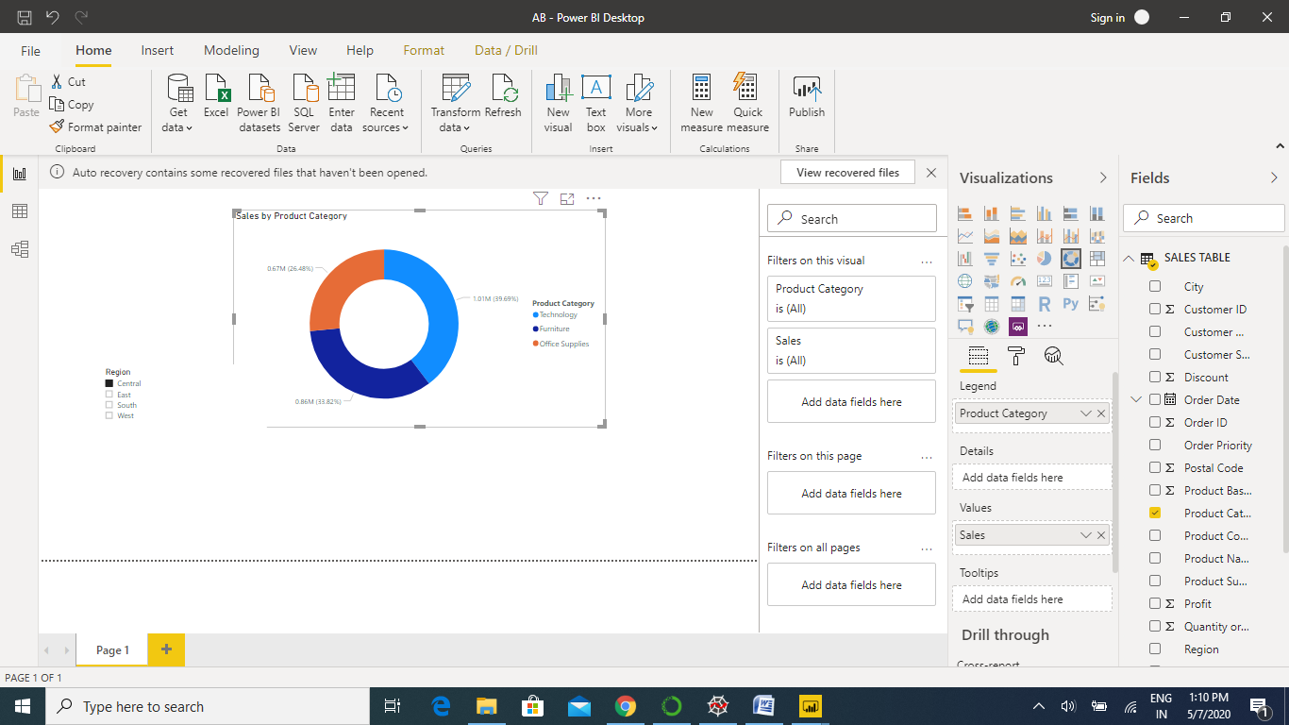

**DATA VIEW**

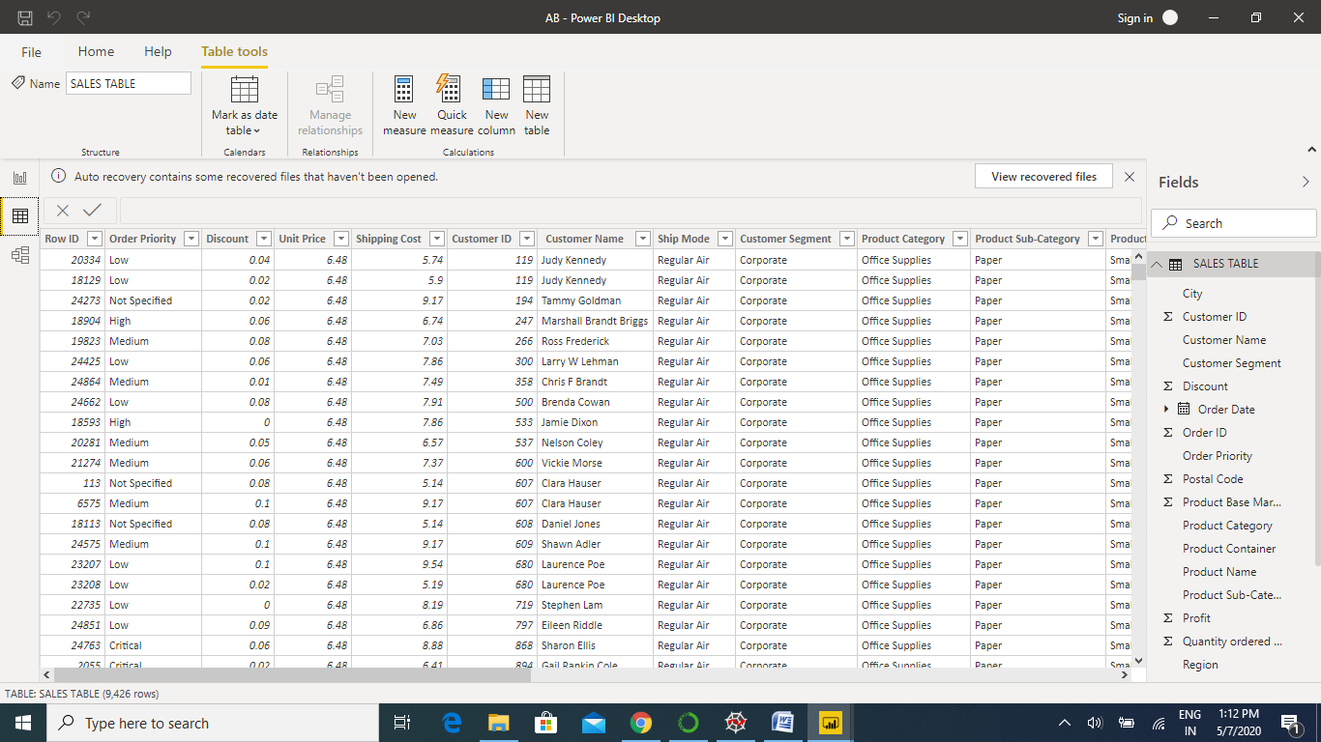

**MODEL VIEW**

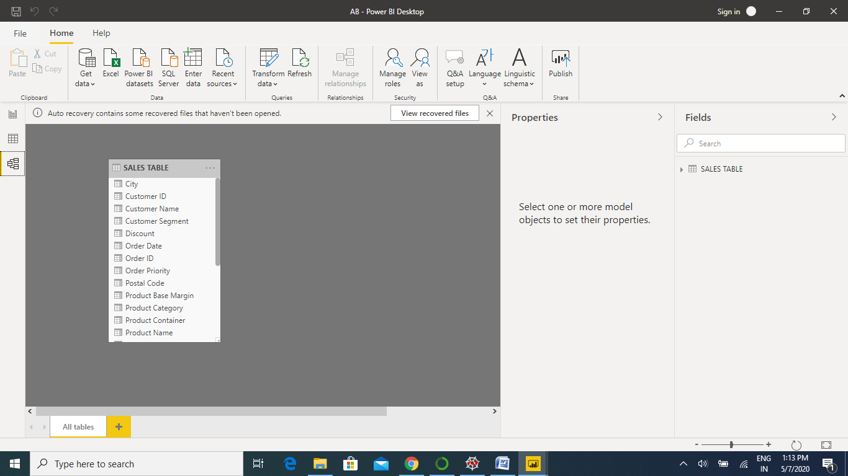

**POWER QUERY EDITOR**

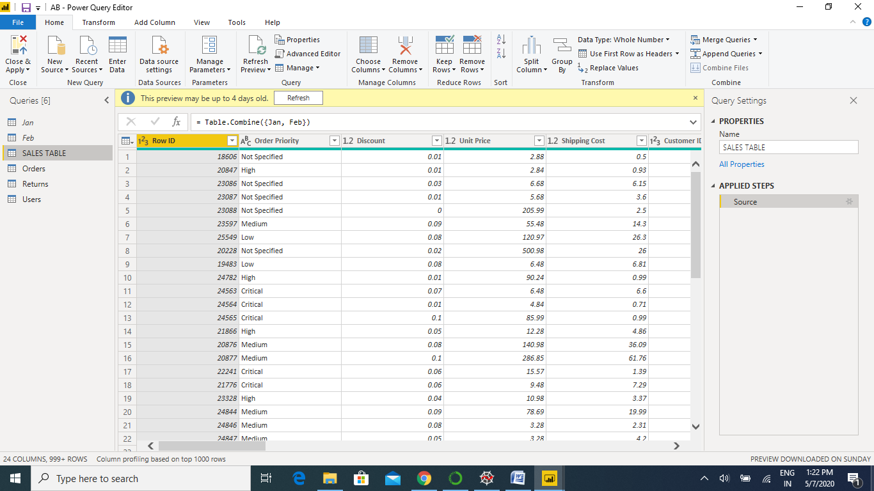

1. **Prepare a document with details of the following along with their price − Power BI Desktop − Power BI Pro − Power BI Premium**

**POWER BI DESKTOP:**

* **Power BI Desktopis a free application** you install on your local computer that lets you connect to, transform, and visualize your data.
* With Power BI Desktop, you can connect to multiple different sources of data, and combine them (often called modeling) into a data model.

The most common uses for Power BI Desktop are as follows:

* Connect to data
* Transform and clean that data, to create a data model
* Create visuals, such as charts or graphs, that provide visual representations of the data
* Create reports that are collections of visuals, on one or more report pages
* Share reports with others by using the Power BI service

The views, shown in the order they appear, are as follows:

* **Report**: In this view, you create reports and visuals, where most of your creation time is spent.
* **Data**: In this view, you see the tables, measures, and other data used in the data model associated with your report, and transform the data for best use in the report's model.
* **Model**: In this view, you see and manage the relationships among tables in your data model.

**POWER BI PRO**

The Biggest difference between free and Pro is that with Pro we can share data, reports, and dashboards with other users who also have a Power Bi Pro licence. You can also create App workplaces. Both Power BI Free and Pro have a 10 GB per Pro user data storage limit.

Power BI Pro price is **$9.99**

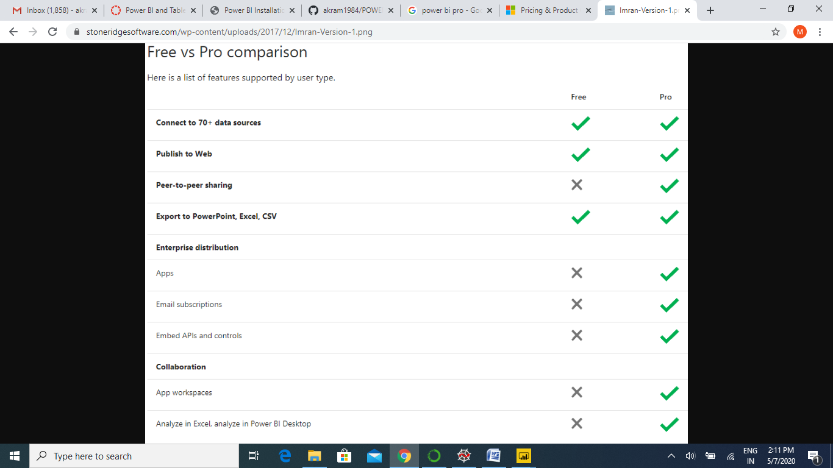

**POWER BI PREMIUM**

For example, with a Power BI Premium subscription, you and your organization's users get access to:

* Greater scale and performance
* Flexibility to license by capacity
* Unify self-service and enterprise BI
* Extend on-premises BI with Power BI Report Server
* Support for data residency by region (Multi-Geo)
* Share data with anyone without purchasing a per-user license

Power BI Premium subscriptions are purchased by administrators in the Microsoft 365 admin center.

Power BI Premium price is **$4,995**